Employee file must be sent in electronic format. The software requires 5-digit zip codes; a report cannot run using 3-digit zip codes. An employee file can be sent with one record/employee or with a count of employees by zip code. Confidential employee information must be removed from the census file before submitting, this includes but is not limited to the employee’s social security number, salary, age, etc. 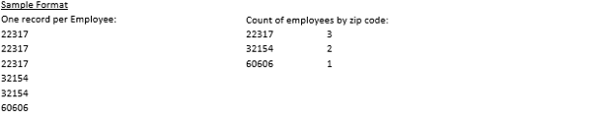
Disruption Analyses (5-Business Day TAT)
Geo Analyses (5-Business Day TAT)
All provider files for a disruption analyses must contain a valid 9-digit Tax ID number. A disruption analyses cannot be done on name only. The file must be in electronic format. Any member information must be scrambled or removed before submitting. Please provide the following fields:
- 9-Digit Tax ID#
- Provider Names (facility and practitioner indicator if available)
- Billed Charges Preferred
Repricing & Savings Analyses (10-Business Day TAT)
A significant amount of claims is needed, typically a year. The file must be in electronic format (Excel, text file or access database). Member information must be scrambled or removed before submitting. For the most accurate analysis, all field are recommended.

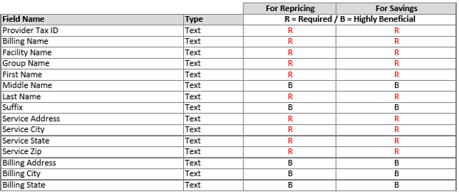
Stop-Loss Data Requirements when Quoting HCH Health Plan

Employer Data Requirments: Name of employer and all subsidiaries to be covered under the policy, Location (ZIP code) of the employer and subsidiaries, Current census (employee ID, age or DOB, gender, active/retired/COBRA, single or dependent coverage) as well as the Standard Industrial Classification (SIC) of the employer and subsidiaries.

Additional Data Requirments: Employer coverage history (past 3 plan years, if available), Insurance carrier or HMO, Dates of coverage, Plan document, summary plan description, schedule of benefits or certificate of coverage. Include all amendments to these documents for the past 3 years. Rate history and any further explination prefered.
If employer was fully insured: premium rates, paid claims and average enrollment by plan year and product are needed.
If employer was self insured: specific deductible, contract type, specific and aggregate premium rates, and aggregate factors are needed. Also needed are monthly paid claims, enrollment by product and Large claims information (shock loss) – Claims which have reached $15,000 or that have exceeded 50% of the proposed specific deductible – Claims expected to exceed 50% of the proposed specific deductible during the proposed policy period.

